Schematic | Potential Problem | Reference Design
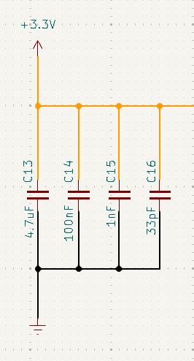 | Way too much decoupling on 3V3 Pin.  Excessive decoupling can cause unwanted resonance, leading to poor noise filtering at certain frequencies. It may also increase inrush current, causing voltage dips during power-up.  Not too risky potentially design will work. | 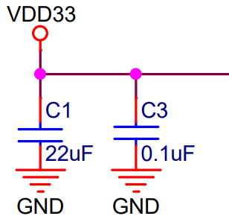
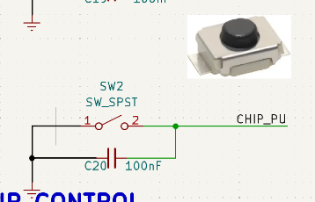  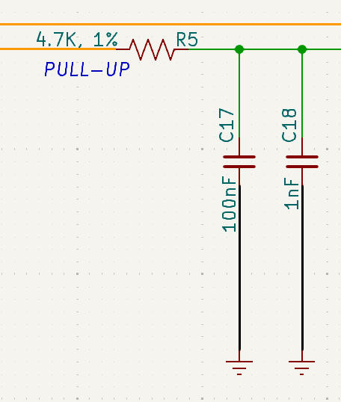 | Total of three capacitor on PU Line (Enable Pin).  Need only on Capacitor (at Max 2 Capacitor) | 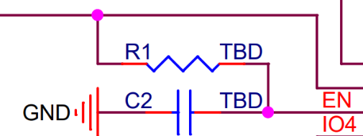  https://www.espressif.com/sites/default/files/documentation/esp32-s3-wroom-1_wroom-1u_datasheet_en.pdf
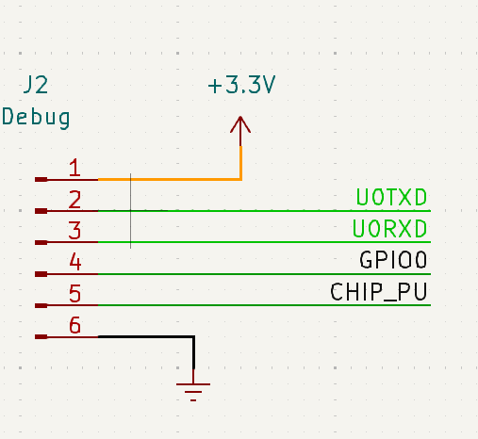 | ESD Protection is missing!
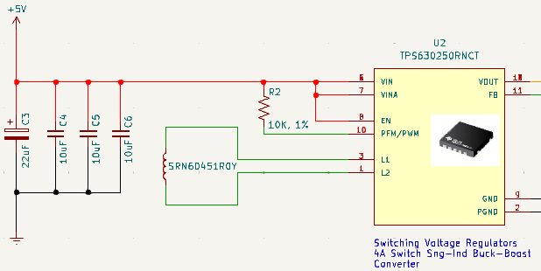 | Only 2 capacitors are needed. 4 capacitors are over kill. Even the value is less then recommended values. | 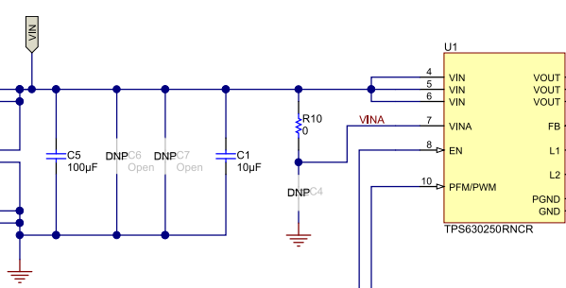  https://www.ti.com/lit/pdf/slvuad2
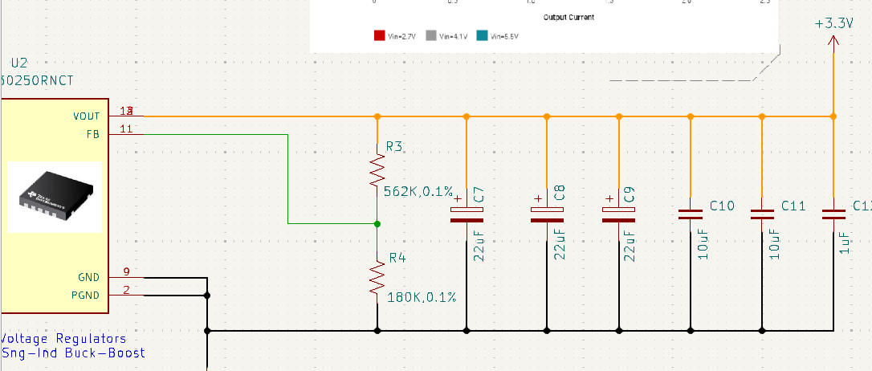 | Same as above | 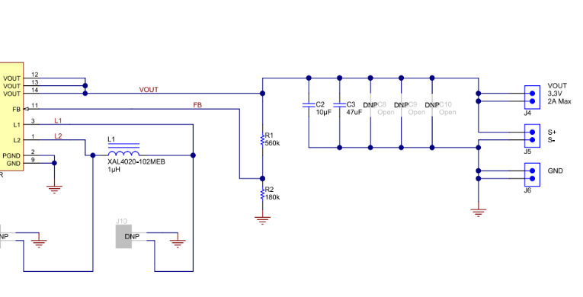
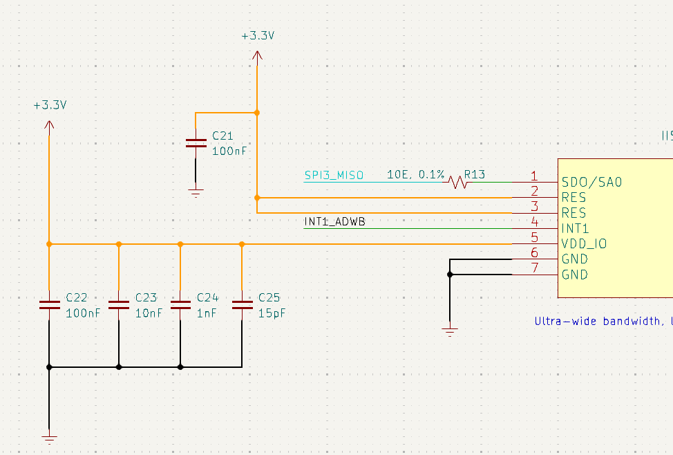 | Ony need 2 Capacitor on VDD and 1 on VDDIO  We have 4 on VDD and 4 on VDDIO | 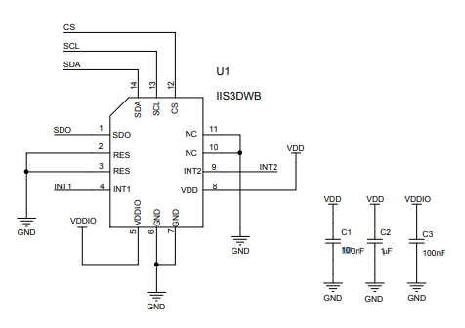  https://www.st.com/resource/en/data_brief/steval-mki208v1k.pdf

